**Pamantasan ng Lungsod ng Muntinlupa**

University Road NBP Reservation, Barangay Poblacion, Muntinlupa City, Philippines

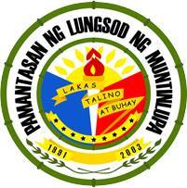

**Outline of Group Report**

**FIL1, Kontekstwalisadong Komuniskasyon sa Filipino**

|  |  |
| --- | --- |
| **Group 1** | |
| **Topic Assigned:** |  |
| **Group Members:** | **Topic Assigned each Members** |
| Blanco, Trixia |  |
| Bravo Jasper |  |
| Del Rosario, Anton Van |  |
| Dionglay, Ralph James |  |
| Eleazar, Cherry Anne |  |
| Evangelista, Aubrey |  |
| Forcadela, Reygenan |  |
| Fuentes, Heart |  |
| Loyola, Reylene Grace |  |
| Petallar, Janine |  |

**Plan**